Scan Converting a Ellipse:
The ellipse is also a symmetric figure like a circle but is four-way symmetry rather than eight-way.
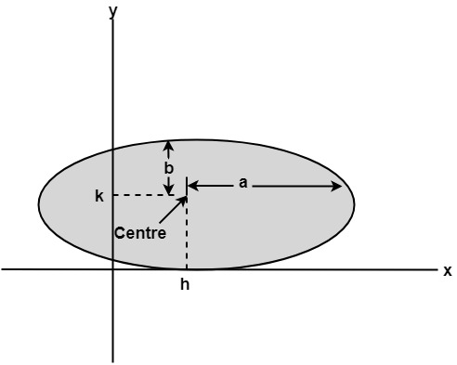

Program to Implement Ellipse Drawing Algorithm:
- #include<stdio.h>
- #include<conio.h>
- #include<graphics.h>
- #include<math.h>
- void disp();
- float x,y;
- intxc,yc;
- void main()
- {
- intgd=DETECT,gm,a,b;
- float p1,p2;
- clrscr();
- initgraph(&gd,&gm,"c:\\turboc3\\bgi");
- printf("*** Ellipse Generating Algorithm ***\n");
- printf("Enter the value of Xc\t");
- scanf("%d",&xc);
- printf("Enter the value of yc\t");
- scanf("%d",&yc);
- printf("Enter X axis length\t");
- scanf("%d",&a);
- printf("Enter Y axis length\t");
- scanf("%d",&b);
- x=0;y=b;
- disp();
- p1=(b*b)-(a*a*b)+(a*a)/4;
- while((2.0*b*b*x)<=(2.0*a*a*y))
- {
- x++;
- if(p1<=0)
- p1=p1+(2.0*b*b*x)+(b*b);
- else
- {
- y--;
- p1=p1+(2.0*b*b*x)+(b*b)-(2.0*a*a*y);
- }
- disp();
- x=-x;
- disp();
- x=-x;
- delay(50);
- }
- x=a;
- y=0;
- disp();
- p2=(a*a)+2.0*(b*b*a)+(b*b)/4;
- while((2.0*b*b*x)>(2.0*a*a*y))
- {
- y++;
- if(p2>0)
- p2=p2+(a*a)-(2.0*a*a*y);
- else
- {
- x--;
- p2=p2+(2.0*b*b*x)-(2.0*a*a*y)+(a*a);
- }
- disp();
- y=-y;
- disp();
- y=-y;
- delay(50);
- }
- getch();
- closegraph();
- }
- void disp()
- {
- putpixel(xc+x,yc+y,7);
- putpixel(xc-x,yc+y,7);
- putpixel(xc+x,yc-y,7);
- putpixel(xc+x,yc-y,7);
- }
Output:
There two methods of defining an Ellipse:
- Polynomial Method of defining an Ellipse
- Trigonometric method of defining an Ellipse

Polynomial Method:
The ellipse has a major and minor axis. If a₁ and b₁are major and minor axis respectively. The centre of ellipse is (i, j). The value of x will be incremented from i to a₁and value of y will be calculated using the following formula
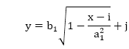

Drawback of Polynomial Method:
- It requires squaring of values. So floating point calculation is required.
- Routines developed for such calculations are very complex and slow.
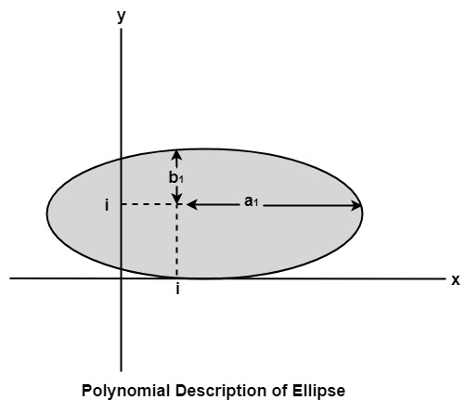

Algorithm:
1. Set the initial variables: a = length of major axis; b = length of minor axis; (h, k) = coordinates of ellipse center; x = 0; i = step; x_{end} = a.
2. Test to determine whether the entire ellipse has been scan-converted. If x>x_{end}, stop.
3. Compute the value of the y coordinate:
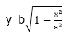
4. Plot the four points, found by symmetry, at the current (x, y) coordinates:
Plot (x + h, y + k) Plot (-x + h, -y + k) Plot (-y - h, x + k) Plot (y + h, -x + k)
5. Increment x; x = x + i.
6. Go to step 2.

Program to draw an Ellipse using Polynomial Method:
- #include <graphics.h>
- #include <stdlib.h>
- #include <math.h>
- #include <stdio.h>
- #include <conio.h>
- #include <iostream.h>

- class bresen
- {
- float x, y, a, b, r, t, te, xend, h, k, step;
- public:
- void get ();
- void cal ();
- };
- void main ()
- {
- bresen b;
- b.get ();
- b.cal ();
- getch ();
- }
- void bresen :: get ()
- {
- cout<<"\n ENTER CENTER OF ELLIPSE";
- cout<<"\n enter (h, k) ";
- cin>>h>>k;
- cout<<"\n ENTER LENGTH OF MAJOR AND MINOR AXIS";
- cin>>a>>b;
- cout<<"\n ENTER Step Size";
- cin>> step;
- }
- void bresen ::cal ()
- {
- /* request auto detection */
- int gdriver = DETECT,gmode, errorcode;
- int midx, midy, i;
- /* initialize graphics and local variables */
- initgraph (&gdriver, &gmode, " ");
- /* read result of initialization */
- errorcode = graphresult ();
- if (errorcode ! = grOK) /*an error occurred */
- {
- printf("Graphics error: %s \n", grapherrormsg (errorcode);
- printf ("Press any key to halt:");
- getch ();
- exit (1); /* terminate with an error code */
- }
- x = 0;
- xend=a;
- whilex (x<xend)
- {
- t= (1-((x * x)/ (a * a)));
- if (t<0)
- te=-t;
- else
- te=t;
- y=b * sqrt (te);
- putpixel (h+x, k+y, RED);
- putpixel (h-x, k+y, RED);
- putpixel (h+x, y-y, RED);
- putpixel (h-x, k-y, RED);
- x+=step;
- }
- getch();
- }
Output:
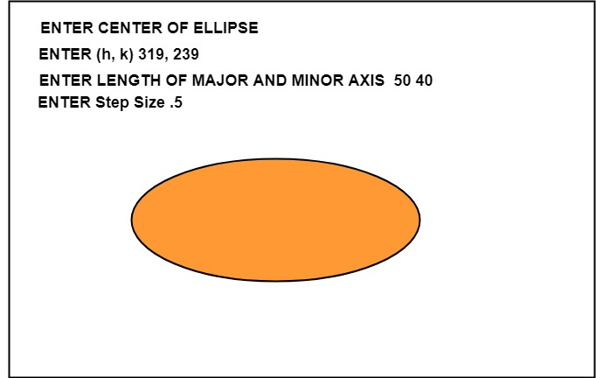

Trignometric Method:
The following equation defines an ellipse trigonometrically as shown in fig:
x = a * cos (θ) +h and
y = b * sin (θ)+k
where (x, y) = the current coordinates
a = length of major axis
b = length of minor axis
θ= current angle
(h, k) = ellipse center
In this method, the value of θ is varied from 0 to radians. The remaining points are found by symmetry.
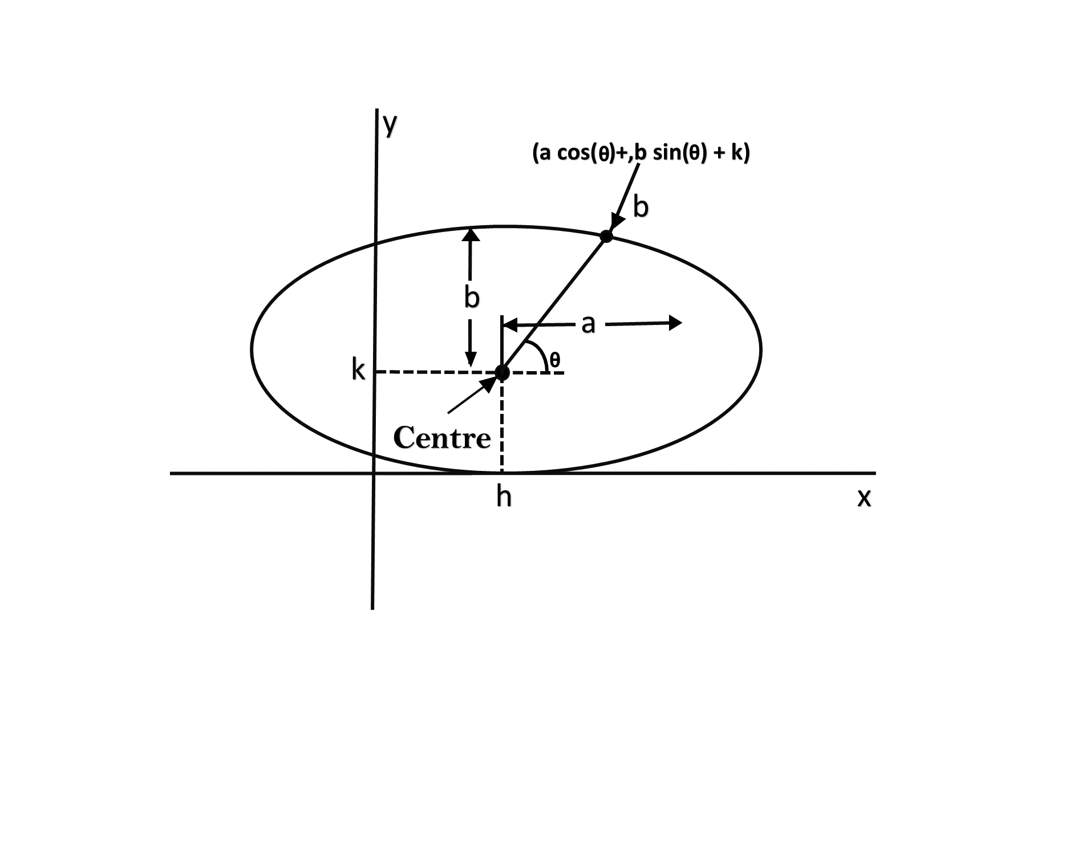

Drawback:
- This is an inefficient method.
- It is not an interactive method for generating ellipse.
- The table is required to see the trigonometric value.
- Memory is required to store the value of θ.

Algorithm:
Step1: Start Algorithm
Step2: Declare variable x₁,y₁,aa₁,bb₁,aa₂,bb₂,fx,fy,p1,a1,b1
Step3: Initialize x₁=0 and y₁=b/* values of starting point of circle */
Step4: Calculate aa₁=a₁*a₁
Calculate bb₁=b₁* b₁
Calculate aa₂=aa₁*2
Calculate bb₂=bb₁*2
Step5: Initialize fx = 0
Step6: Initialize fy = aa_2* b₁
Step7: Calculate the value of p₁and round if it is integer
p₁=bb₁-aa₁* b₁+0.25* aa₁/
Step8:
While (fx < fy)
{
Set pixel (x₁,y₁)
Increment x i.e., x = x + 1
Calculate fx = fx + bb₂
If (p1 < 0)
Calculate p1 = p1 + fx + bb₁/
else
{
Decrement y i.e., y = y-1
Calculate fy = fy - 992;
p1=p1 + fx + bb₁-fy
}
}
Step9: Setpixel (x₁,y₁)
Step10: Calculate p1=bb₁ (x+.5)(x+.5)+aa(y-1)(y-1)-aa₁*bb₁
Step 11:
While (y₁>0)
{
Decrement y i.e., y = y-1
fy=fx-aa₂/
if (p1>=0)
p1=p1 - fx + aa₁/
else
{
Increment x i.e., x = x + 1
fx= fx+bb_2
p1=p1+fx-fy-aa₁
}
}
Set pixel (x₁,y₁)
Step12: Stop Algorithm

Program to draw a Ellipse using Trigonometric method:
- #include <graphics.h>
- #include <stdlib.h>
- #include <math.h>
- #include <stdio.h>
- #include <conio.h>
- #include <iostream.h>
- # define pi 3.14

- class bresen
- {
- float a, b, h, k, thetaend,step,x,y;
- int i;
- public:
- void get ();
- void cal ();
- };
- void main ()
- {
- bresen b;
- b.get ();
- b.cal ();
- getch ();
- }
- void bresen :: get ()
- {
- cout<<"\n ENTER CENTER OF ELLIPSE";
- cin>>h>>k;
- cout<<"\n ENTER LENGTH OF MAJOR AND MINOR AXIS";
- cin>>a>>b;
- cout<<"\n ENTER STEP SIZE";
- cin>> step;
- }
- void bresen ::cal ()
- {
- /* request auto detection */
- int gdriver = DETECT,gmode, errorcode;
- int midx, midy, i;
- /* initialize graphics and local variables */
- initgraph (&gdriver, &gmode, " ");
- /* read result of initialization */
- errorcode = graphresult ();
- if (errorcode ! = grOK) /*an error occurred */
- {
- printf("Graphics error: %s \n", grapherrormsg (errorcode);
- printf ("Press any key to halt:");
- getch ();
- exit (1); /* terminate with an error code */
- }
- theta= 0;
- thetaend=(pi*90)/180;
- whilex (theta<thetaend)
- {
- x = a * cos (theta);
- y = b * sin (theta);
- putpixel (x+h, y+k, RED);
- putpixel (-x+h, y+k, RED);
- putpixel (-x+h, -y+k, RED);
- putpixel (x+h, -y+k, RED);
- theta+=step;
- }
- getch();
- }
Output:
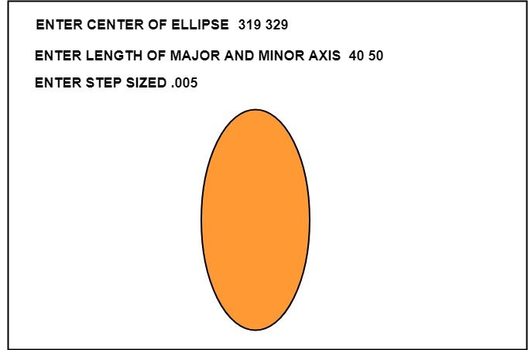

Ellipse Axis Rotation:
Since the ellipse shows four-way symmetry, it can easily be rotated. The new equation is found by trading a and b, the values which describe the major and minor axes. When the polynomial method is used, the equations used to describe the ellipse become
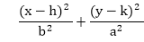
where (h, k) = ellipse center
a = length of the major axis
b = length of the minor axis
In the trigonometric method, the equations are
x = b cos (θ)+h and y=a sin(θ)+k
Where (x, y) = current coordinates
a = length of the major axis
b = length of the minor axis
θ = current angle
(h, k) = ellipse center
Assume that you would like to rotate the ellipse through an angle other than 90 degrees. The rotation of the ellipse may be accomplished by rotating the x &y axis α degrees.
x = a cos (0) - b sin (0+ ∞) + h y= b (sin 0) + a cos (0+∞) + k
